**Project 1 – Brexit**

Is the emergence of businesses noticeably different in Voting Precincts that voted to stay vs Voting Precincts that voted to leave?

* Voting precincts that voted ‘For’ Brexit had a lower number of businesses emerging each year compared to the voting precincts who voted ‘Against’ Brexit.

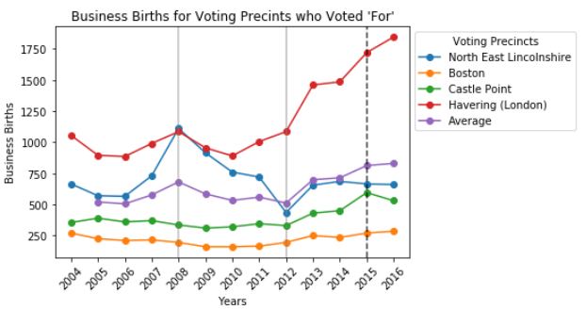

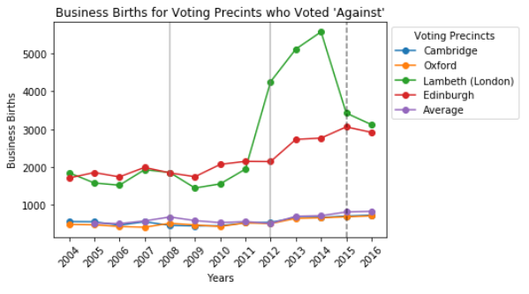

* Two different voting precincts from the city of London had vast differences in voting decision and business growth over the same time period (Lambeth and Havering).

To me, both of these findings indicate that there could be some correlation to the number of business being created in these voting precincts and how they are voting towards Brexit. The next steps I would want to take would be to compare the sample voting precincts to the population of all precincts that voted the same way on Brexit to see if these samples are indicative of the population. I would have a Null Hypothesis of: The sample of voting precincts of ‘For’ and ‘Against’ do not have the same average number of businesses emerging each year than the population of voting precincts of ‘For’ and ‘Against’.

In addition, with the data only going through 2016, I would be interested in pulling down more recent years’ data as it becomes available to further each trend line and re-reun the analyses to determine if anything has changed or more questions arise.

